Monkeypox Tip Sheet
For suspected/confirmed case, call Infection Prevention immediately
Business hours (M-F 8AM- 4PM): Adults 628-248-9059 & Pediatrics 628-248-8503 After hours: Moffitt-Long 415-353-8036; BCH-SF 415-502-0728, MB Adults 415-502-0562

Consider the diagnosis
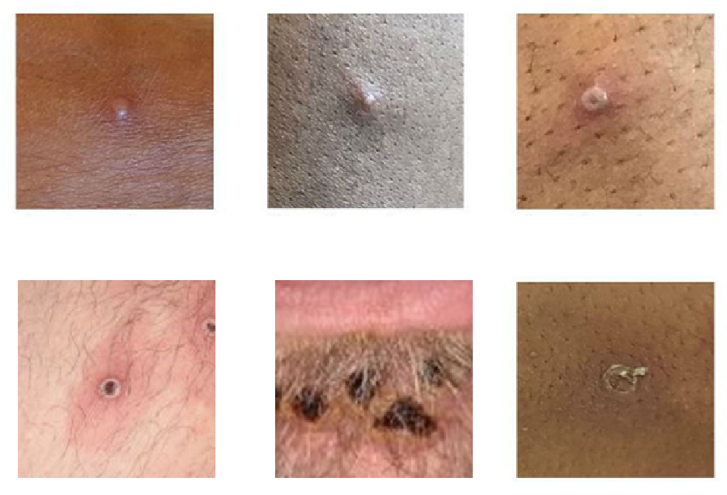
Classic presentation includes a flu-like illness lasting days followed by a characteristic disseminated rash.
Some recent monkeypox cases are presenting atypically: with no prodrome, localized genital/perianal lesions.
Classic rash progression: macules--> papules--> vesicles--> pustules filled with yellowish fluid--> crusts. Lesions are deep- seated, firm/hard, well-circumscribed, lesions may umbilicate or become confluent.
Rash may be confused for HSV, VZV, syphilis, molluscum, chancroid.

Isolate
Initiate Contact, Droplet, and Airborne Isolation. Room the patient right away.
Place the patient in a single room with the door closed. Use an Airborne Isolation room if available. Ensure patient is wearing a mask if there are no medical or age contraindications.

Personal Protective Equipment and Disinfectants
Use a fit tested N95/eye protection (or PAPR), gloves and gown including for cleaning the room and handling linen.
Routine hospital grade disinfectants are appropriate for cleaning.

Reporting
In addition to calling Infection Prevention, immediately call SF Department of Health (SFDPH) 415-554-2830 to report the case and get approval for monkeypox testing.

Testing
Get SFDPH approval for testing. Refer to this guidance for testing.
Order ‘Microbiology-Test Not Listed (special send out) P319’, specify monkeypox as test requested. Notify the micro lab 415-353-1268 prior to sending the test.

Treatment
Call the clinical infectious disease team for guidance on treatment Department of Health Adult patients via Voalte or 415-443-8996, Pediatrics 415-443-2384
6/13/22
For more information, refer to these additional resources

