Aerosol-Generating Procedure
In Progress
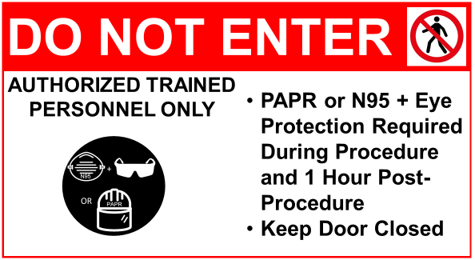
TIME PROCEDURE ENDED: |  | TIME ROOM IS AVAILABLE:
 |  | (60 Minutes Post-Procedure)

